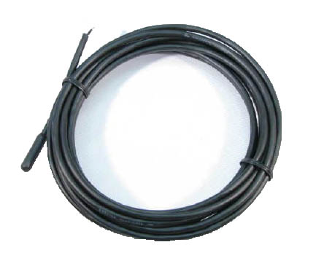

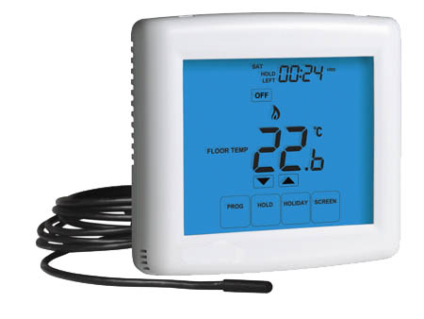

Application

|  |  |  |  |
| --- | --- | --- | --- |
| Temp (°C) | R. (ohm) | | A.R (+/- %) |
| 0 | | 41093 | 6.1 |
| 5 | | 33209 | 5.9 |
| 10 | | 26988 | 5.7 |
| 15 | | 22074 | 5.5 |
| 20 | | 18148 | 5.2 |
| 25 | | 15000 | 5.0 |
| 30 | | 12462 | 5.2 |
| 35 | | 10404 | 5.4 |
| 40 | | 8728 | 5.6 |
| 45 | | 7355 | 5.8 |
| 50 | | 6226 | 5.9 |

v

Feature

***Underfloor Heating Probe***

* Degree of Protection: Waterproof to **IP67**
* Temperature Range: - 50 to 105°C
* Cable : 0.30 sqmm standard copper
* First insulation PP. Secondary Insulation thermoplastic elastomer. Colour Black
* Hardness 50 shore D
* Halogen- free cable
* Strength of cable : 200N
* Tip: Thermoplastic elastomer overmoulded on the cable
* Insulation resistance: 100MΩ at 1000V DC
* Dielectric Strength: 3000V AC